**Task 2**

**Q 1:** Define software testing and explain its significance in the software development lifecycle. What are the primary objectives of software testing, and how does it contribute to the quality of a software product?

Ans: Software testing is defined as an activity to check whether the actual results match the expected results and to ensure that the software system is Defect free. Testing is important because software bugs could be expensive or even dangerous.

Software testing identifies bugs and issues in the development process so they're fixed prior to product launch. This approach ensures that only quality products are distributed to consumers, which in turn elevates customer satisfaction and trust. The main aim of testing is to maintain the quality of the product.

**Q 2:** Describe various types of software applications (e.g., web, mobile, desktop) and the key differences between them. How does the type of application impact the testing approach and strategies?

Ans:

* **Word-processing software:-**It makes use of a computer for creating, modifying, viewing, storing, retrieving, and printing documents.
* **Spread sheet software:-**Spread sheet software is a numeric data-analysis tool that allows you to create a computerized ledger.
* **Database software:-**A database software is a collection of related data that is stored and retrieved according to user demand.
* **Graphics software:-**It allows computer systems for creating, editing, drawings, graphs, etc.
* **Education software:-**Education software allows a computer to be used as a learning and teaching tool.
* **Entertainment software:-**This type of app allows a computer to be used as an entertainment tool.

**Q 3:** List and explain the different levels of software testing. Provide examples of test activities or tasks associated with each testing level and their respective objectives.

Ans:

1. **Unit Testing** : checks if software components are fulfilling functionalities or not. A [Unit](https://www.guru99.com/unit-testing-guide.html) is a smallest testable portion of system or application which can be compiled, liked, loaded, and executed. This kind of testing helps to test each module separately.
2. **Integration Testing** : checks the data flow from one module to other modules. [Integration](https://www.guru99.com/integration-testing.html) means combining. For Example, In this testing phase, different software modules are combined and tested as a group to make sure that integrated system is ready for system testing.
3. **System Testing** : evaluates both functional and non-functional needs for the testing. [System testing](https://www.guru99.com/system-testing.html) is performed on a complete, integrated system. It allows checking system’s compliance as per the requirements. It tests the overall interaction of components. It involves load, performance, reliability and security testing.
4. **Acceptance Testing** : checks the requirements of a specification or contract are met as per its delivery. [Acceptance testin](https://www.guru99.com/user-acceptance-testing.html)g is a test conducted to find if the requirements of a specification or contract are met as per its delivery. Acceptance testing is basically done by the user or customer.

**Q 4:** Define mandatory testing in the context of software testing. Describe different types of mandatory testing (e.g., compliance testing, security testing) and provide reasons why each type is essential in software testing.

Ans: The Mandatory Testing and Disclosure Act provides a method for certain individuals exposed to the risk of communicable disease infection through contact with another person to compel that person to provide a bodily substance for testing, if such information cannot reasonably be obtained in any other manner .

**Q 5:**  Explain the bug (defect) life cycle in software testing. Outline the various stages a bug goes through from identification to resolution. What role does the bug tracking system play in managing the bug life cycle?

Ans: **Defect Life Cycle** or Bug Life Cycle in software testing is the specific set of states that defect or bug goes through in its entire life.

[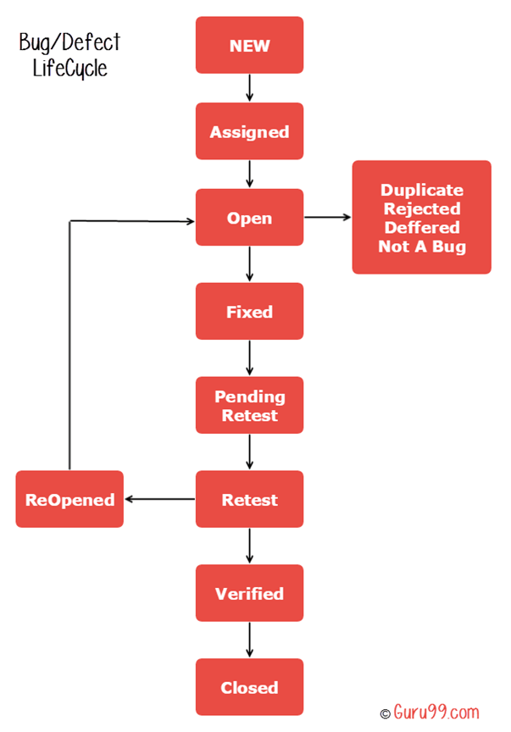](https://www.guru99.com/images/1-2015/012715_0802_BugLifeCycl1.png)

* **New**: When a new defect is logged and pasted for the first time. It is assigned a status as New.
* **Assigned**: Once the bug is posted by the tester the lead of the tester approves the bug and assigns the bug to the developer team.
* **Open**: The developer start analysing and works on the defect fix.
* **Fixed**: When the developer makes a necessary code change and verifies the change, he or she can make bug status as Fixed.
* **Re**-**tested**: Once the defect is fixed the developer gives a particular code for retesting the code to the tester.
* **Verified**: The tester re-tests the bug after it got fixed by the developer. If there is no bug detected in the software, then the bug is fixed and the status assigned is “verified.”
* **Reopen**: If the bug persists even after the developer has fixed the bug, the tester changes the status to “reopened”. Once again the bug goes through the life cycle.
* **Closed**: If the bug is no longer exists then tester assigns the status “Closed.”
* **Duplicate**: If the defect is repeated twice or the defect corresponds to the same concept of the bug, the status is changed to “duplicate.”
* **Rejected**: If the developer feels the defect is not a genuine defect then it changes the defect to “rejected.”
* **Deferred**: If the present bug is not of a prime priority and if it is expected to get fixed in the next release, then status “Deferred” is assigned to such bugs
* **Not a bug**: If it does not affect the functionality of the application then the status assigned to a bug is “Not a bug”.